SCIENTIFIC INQUIRY PRACTICE - PHOTOSYNTHESIS

QUESTION: Robert set up this experiment (below right) to find out (how light affects the rate at which plants make their own food by photosynthesis.
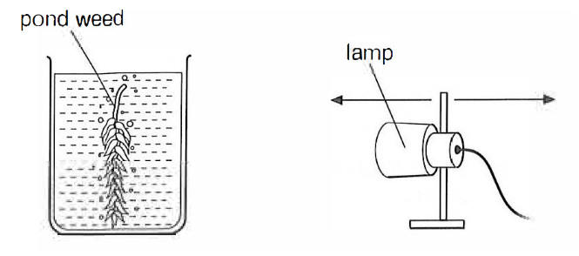
- Robert put the lamp 100 cm away from the plant and counted the number of bubbles made by the plant in one minute.
- He then moved the lamp nearer to the beaker and counted the number of bubbles again.
This table shows his results
Distance from Lamp (cm) | Number of Bubbles per minute
 | Trial 1 | Trial 2 | Trial 3 | Average | Uncertainty
100 | 9 | 12 | 8 | 10 | 2
80 | 19 | 19 | 22 | 20 | 1.5
60 | 32 | 23* | 33 | 33 | 0.5
40 | 34 | 40 | 37 | 37 | 3
20 | 36 | 37 | 38 | 37 | 1
*anomaly
- Plot the points on a piece of graph paper (below).

- Draw the line of best fit on your grid.

- Predict the number of bubbles per minute if the lamp is placed 10 cm from the plant.

- Use these results to identify the trend in the data: As the distance from the lamp ________, the rate of photosynthesis ___________.

- Use the results to draw a conclusion: As light intensity _______________, the rate of photosynthesis _______________.

(e) Use your knowledge of what limits photosynthesis to explain the shape of the graph

